**Ex No 4**

# Create UDF (User Defined Functions) in Apache Pig and execute it in MapReduce / HDFS mode

**AIM:**

To create UDF in Apache Pig and execute it in MapReduce/HDFS mode.

**PROCEDURE:**

## 1. Install Apache Pig

**Download Pig:**

1. Download Pig from the Apache Pig download page:

Link: [Apache](https://downloads.apache.org/pig/pig-0.17.0/) [Pig](https://downloads.apache.org/pig/pig-0.17.0/) [0.17.0](https://downloads.apache.org/pig/pig-0.17.0/) [Download](https://downloads.apache.org/pig/pig-0.17.0/)

Extract the downloaded file (assuming you downloaded pig-0.17.0.tar.gz):

tar -xzf pig-0.17.0.tar.gz

Move the extracted folder to a directory, such as /usr/local/:

sudo mv pig-0.17.0 /usr/local/pig

## 2. Set Up Environment Variables for Pig

Edit your ~/._profile or ~/.zshrc to include Pig in the PATH.

nano ~/.zshrc

Add the following lines:

export PIG_HOME=/usr/local/pig export PATH=$PIG_HOME/bin:$PATH

Apply the changes: source ~/.zshrc

## 3. Verify Pig Installation

Run the following command to check if Pig is installed correctly: pig -x local

You should see the Pig Grunt shell prompt:

grunt>

Type quit to exit the shell.

## 4. Start Hadoop Services

Make sure your Hadoop is up and running. Start the required services:

cd /usr/local/hadoop/sbin

./start-dfs.sh

./start-yarn.sh

## 5. Prepare Input Data (ex4.txt)

Create a sample text file for testing the UDF, named ex4.txt:

nano ex4.txt

Example content:

1,John

2,Soniya

3,Vijay 4,Sonu

Upload the file to HDFS:

hdfs dfs -mkdir /UDF hdfs dfs -put ex4.txt /UDF/

## 6. Create UDF in Python

Now, you need to write your Python UDF.

Create a Python file uppercase_udf.py:

nano uppercase_udf.py

Add the following code to uppercase_udf.py: #!/usr/bin/python3 def uppercase(text):

return text.upper()

if __name__ == "__main__": import sys for line in sys.stdin: line = line.strip() result = uppercase(line) print(result)

Upload the Python UDF to HDFS:

hdfs dfs -mkdir /UDF/udfs hdfs dfs -put uppercase_udf.py /UDF/udfs/

Make sure the file is in the correct HDFS directory by running:

hdfs dfs -ls /UDF/udfs

**7. Write Pig Script (UDF.pig)** Create a Pig script to apply your UDF.

Create UDF.pig: nano UDF.pig

Add the following Pig script to UDF.pig:

-- Register the UDF

REGISTER hdfs:///UDF/udfs/uppercase_udf.py USING jython AS myudfs;

-- Load the ex4.txt file from HDFS

data = LOAD 'hdfs:///UDF/ex4.txt' USING PigStorage(',') AS (id:int,name:chararray);

-- Apply the UDF to each line

uppercase_data = FOREACH data GENERATE myudfs.uppercase(name) AS upper_line;

-- Store the result in HDFS

STORE uppercase_data INTO 'hdfs:///UDF/output' USING PigStorage(',');

Save the file and exit.

## 8. Run the Pig Script in MapReduce Mode

Now that everything is set up, execute the Pig script in MapReduce mode:

hdfs dfs -chmod 755 /UDF/udfs/uppercase_udf.py hdfs dfs -chmod 755 /UDF hdfs dfs -chmod 755 /UDF/ex4.txt

pig -x mapreduce UDF.pig

## 9. Check the Output

After the job finishes, you can view the output in HDFS.

List the output directory:

hdfs dfs -ls /UDF/output

You should see something like:

Found 1 items

-rw-r--r-- 3 user group 123 2024-09-11 12:00

/UDF/output/part-m-00000

View the output file:

hdfs dfs -cat /UDF/output/part-m-00000

You should see the content in uppercase

**OUTPUT:**

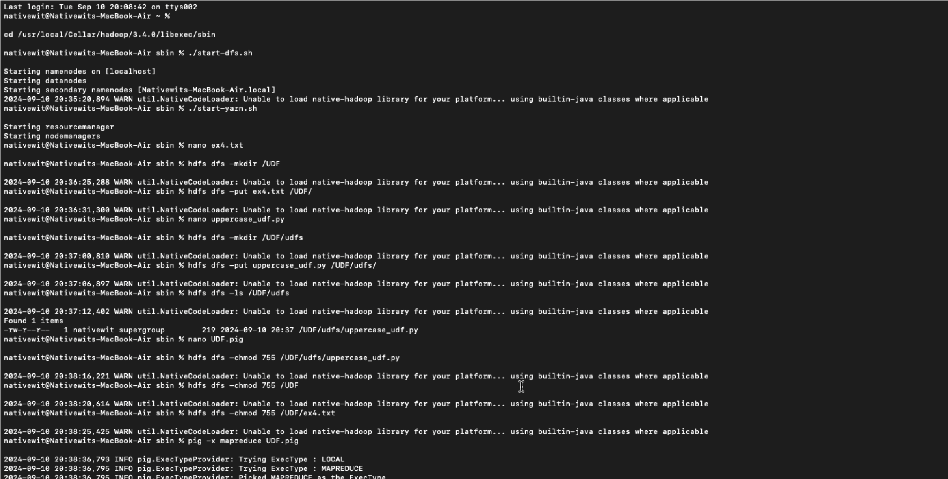

**RESULT:**

Thus, UDF in Apache Pig has been created and executed in MapReduce/HDFS mode successfully.